Documentation
FM Becomes Speaker (Curie Maharani Savitri) - Webinar “Shaping Tomorrow: Exploring Opportunities in the Southeast Asian Defence Industries”
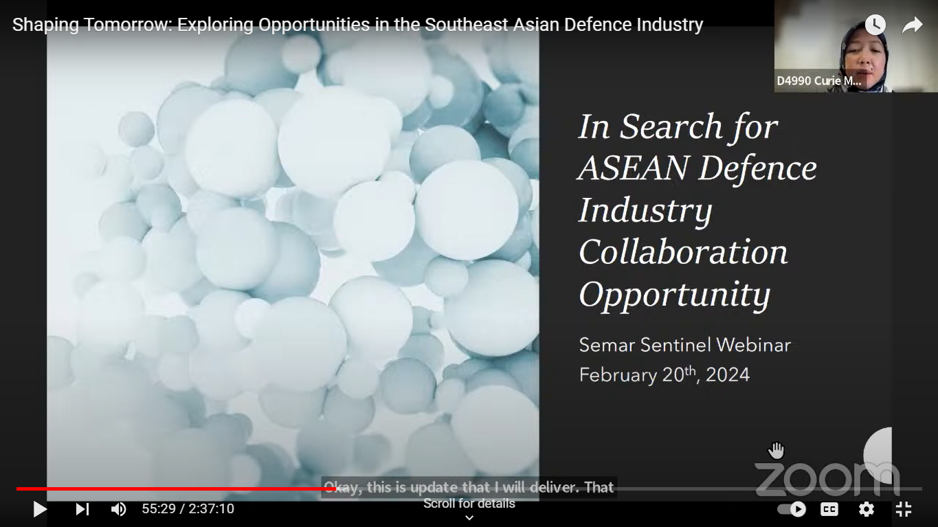
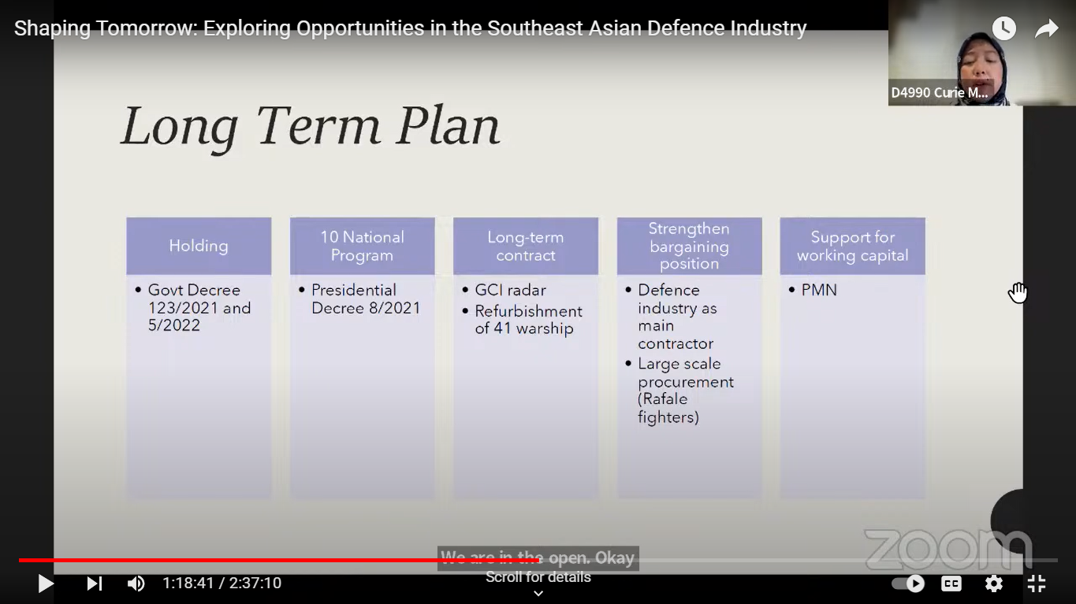
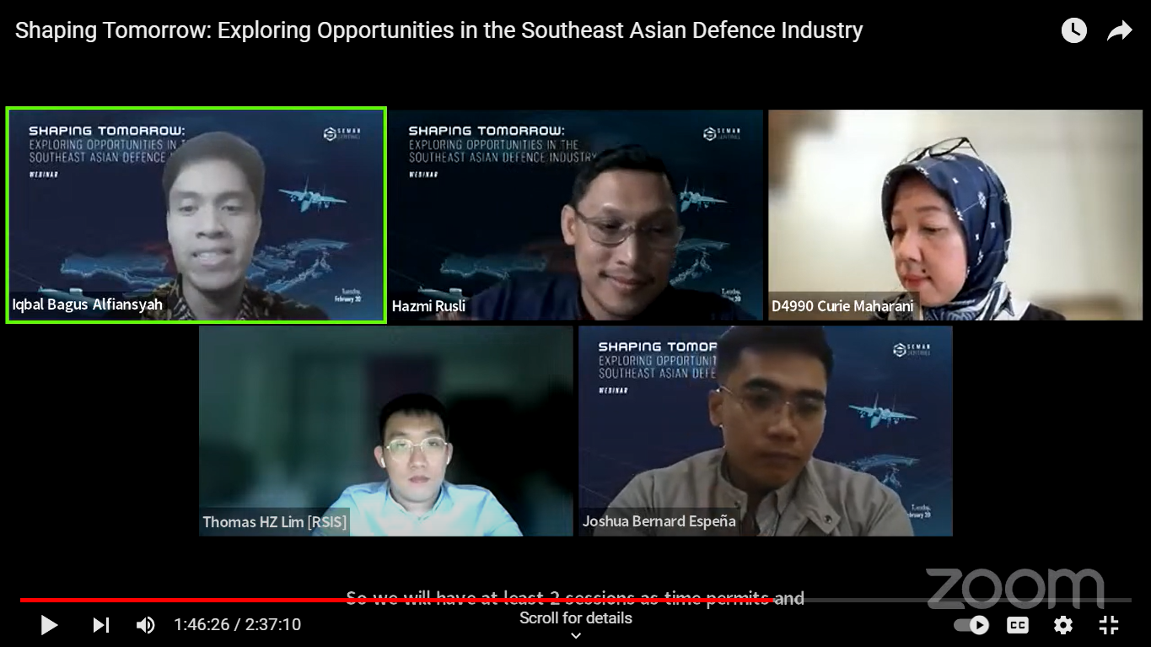
https://www.youtube.com/watch?v=TOLvI1X623U

